1. Use official documentation to install Chronograf:

URL - <https://portal.influxdata.com/downloads/>

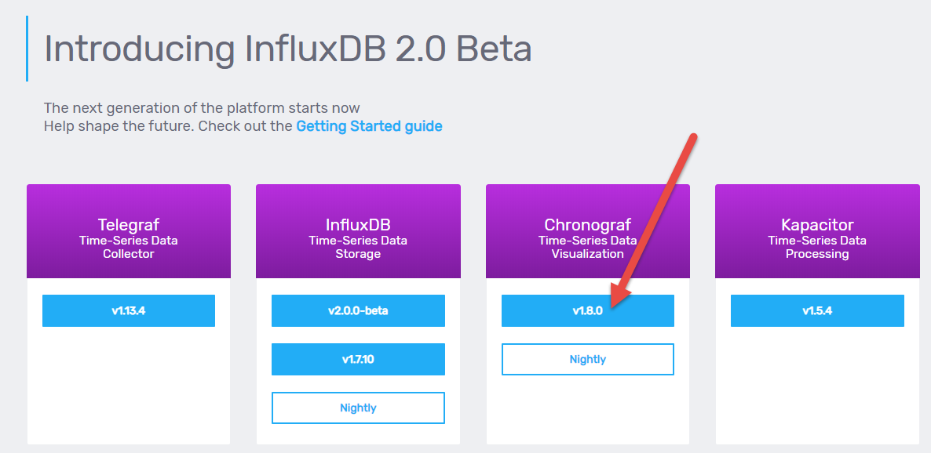

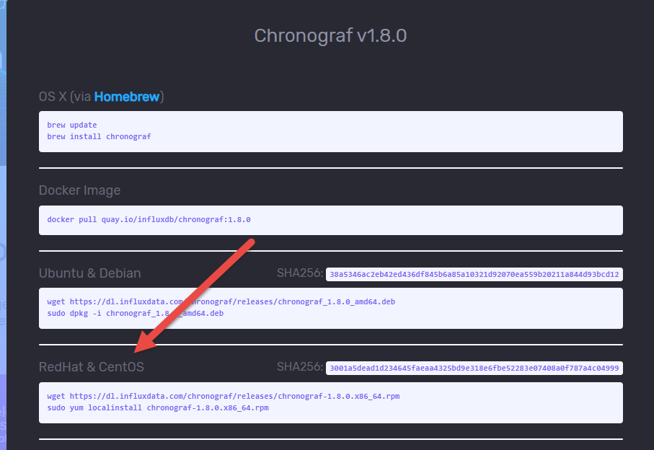

By default chronograf should be accessible on port 8888

1. Use official documentation to install Kapacitor:

URL - <https://portal.influxdata.com/downloads/>

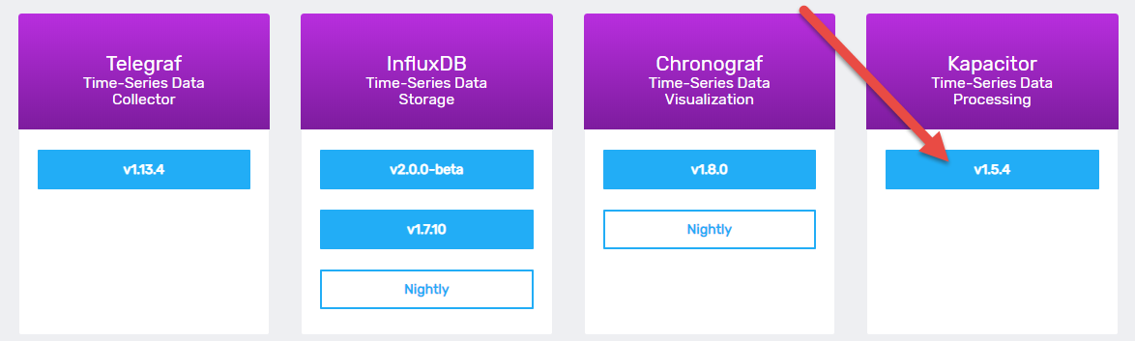

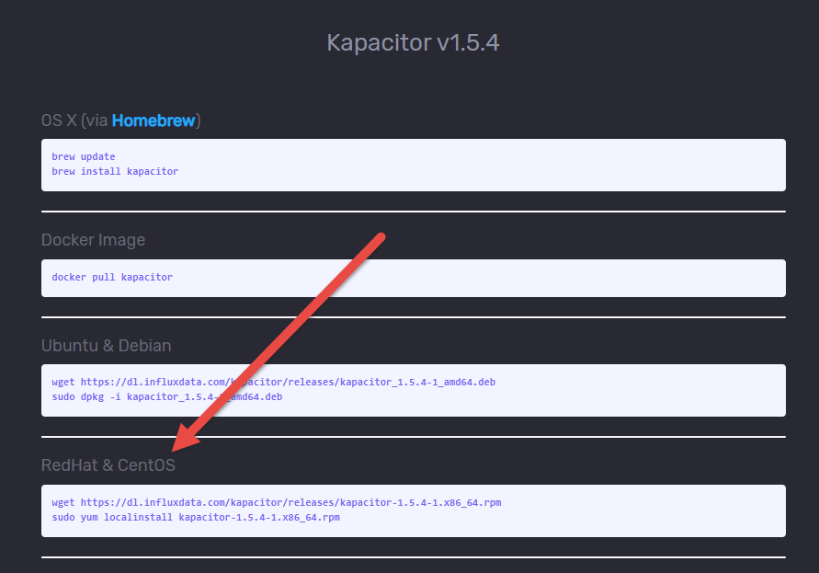

1. Connect Kapacitor and InfluxDB to Chronograf

Go to http://x.x.x.x:8888

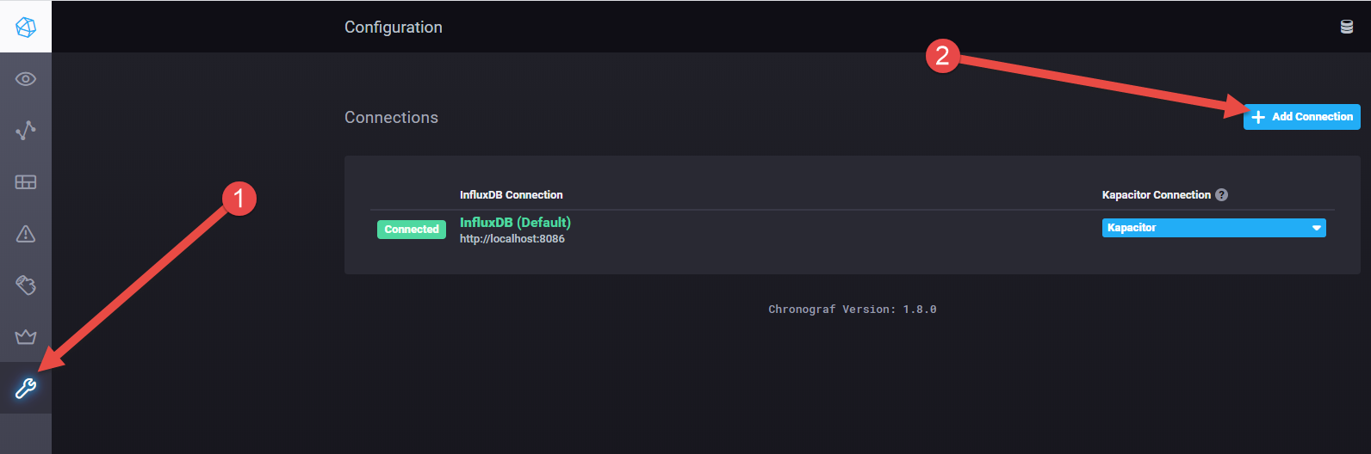

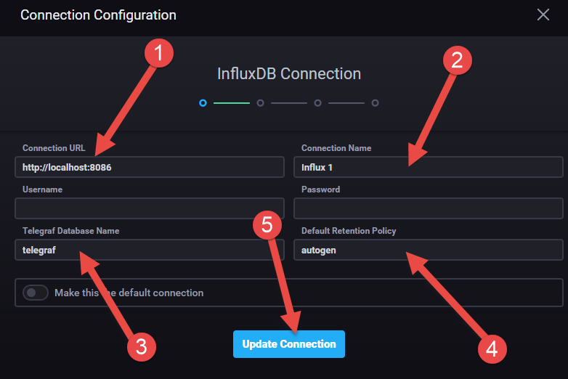

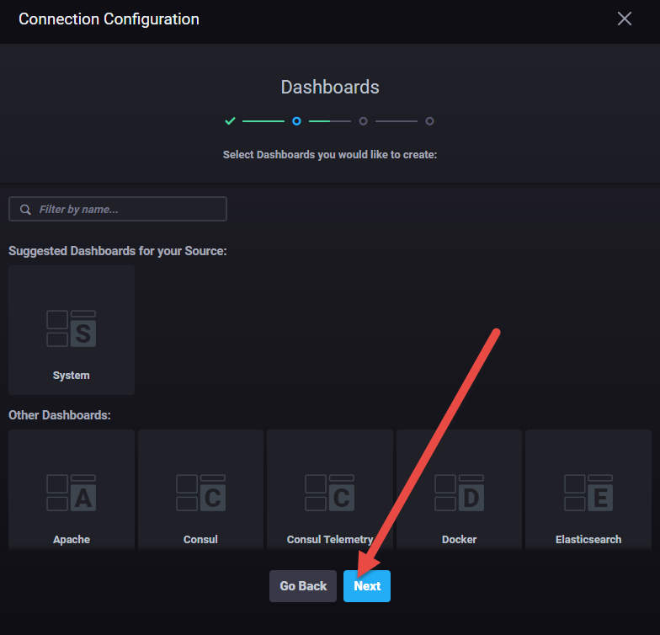

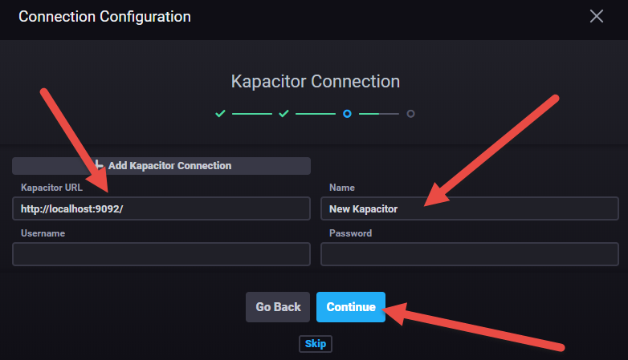

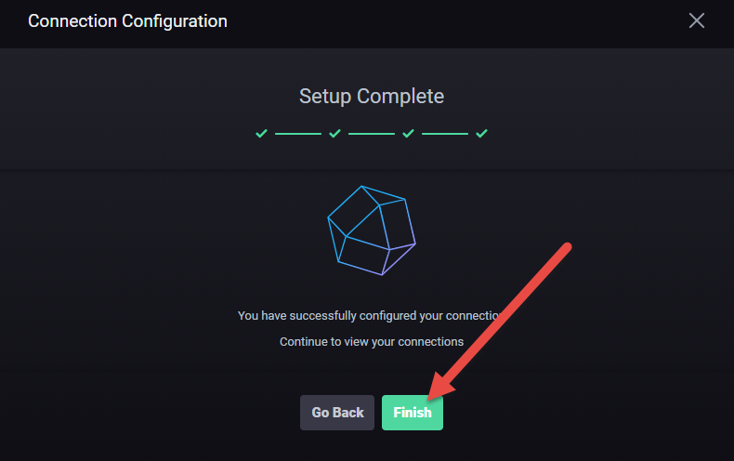

1. Check list of available connections (You can connect multiple InfluxDB instances to the same Chronograf)

